**Goyang Festival**

Each spring and autumn, the Ilsan Lake Park in Goyang, Korea, a city just outside of Seoul is decorated with flowers for a gorgeous flower festival that is the perfect way to welcome the new colorful season. We went a few years ago and have kept going back each year to just watch as it has gotten bigger and better each year.

Here’s a little guide to Ilsan Lake Park and how to enjoy a day out in the area.

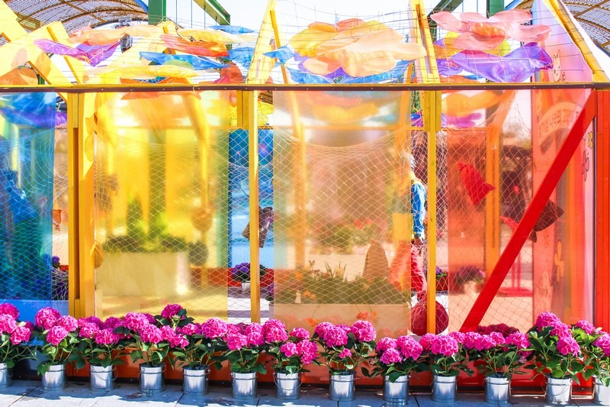

How To Get There

**Address:**595 Hosu-ro, Ilsandong-gu, Goyang-si, Gyeonggi-do (경기도 고양시 일산동구 호수로 595)

**By public transportation:**Though Goyang is a suburb of Seoul, you might be surprised to learn that the subway system does indeed go out there. The best station to choose to get to Ilsan Lake Park is Jeongbalsan Station on the orange line. Take either exit 1 or 2 to head to the park.

**The Ilsan Lake Park Flower Festivals**

Ilsan Lake Park actually hosts two major flower festivals in the year. The annual spring flower festival hosted at Ilsan Lake Park is the International Horticulture Goyang Korea (고양국제꽃박람회) and the annual fall flower festival hosted at Ilsan Lake Park is the Goyang Autumn Flower Festival (고양가을꽃축제). Two festivals, two different names, two seasons, same location.

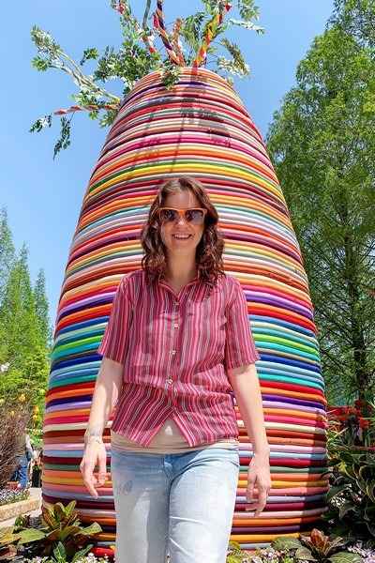

Goyang International Flower Festival: The Goyang International Flower Festival is one of the most anticipated events in South Korea, and the 2023 edition promises to be bigger and better than ever before. Scheduled to take place from April 27 to May 8, the festival will be held at the picturesque Ilsan Lake Park, which boasts an expansive area of 100,000 square meters. The festival will be open to visitors from 10:00 a.m. to 9:00 p.m. daily, allowing ample time to explore the beautiful displays and participate in the various events.The festival’s theme this year is Flower in the Life, which seeks to highlight the importance of flowers in our daily lives. Visitors can expect to see stunning flower displays and participate in various activities such as the flower industry exhibition, the Goyang International Flower Forum, the Goyang International Flower Awards, and the Goyang Flower Market. Additionally, there will be a diverse range of performances, including indie band concerts, street jazz band performances, magic shows, and more.To attend the festival, visitors can purchase tickets online at Naver from April 1 to 26, with early bird adult tickets priced at 11,000 KRW.General ticket sales will commence from April 27 to May 8, with adult tickets priced at 15,000 KRW.